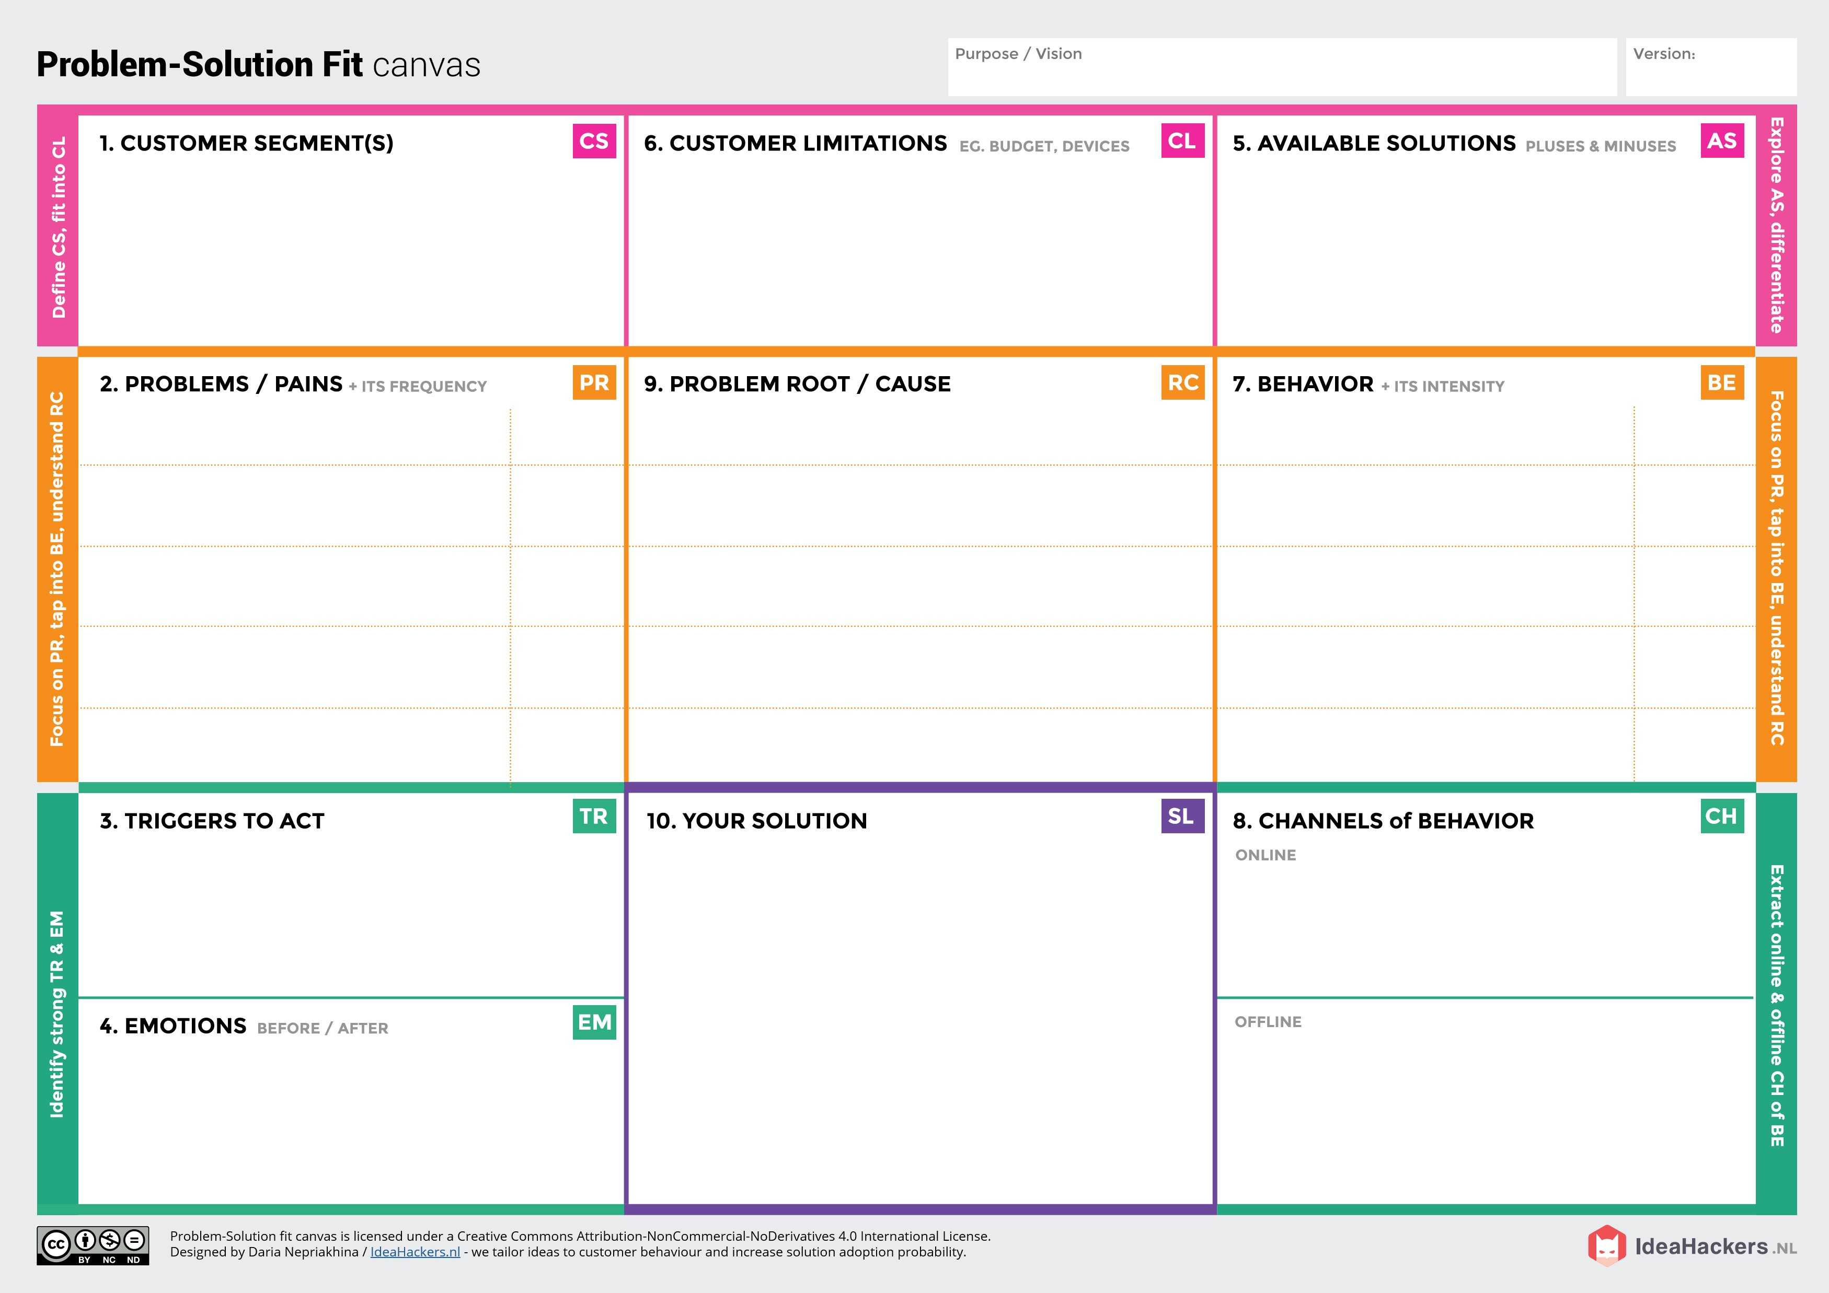bb,l

**PROJECT TITLE:** SMART FARMING USING IOT **PROJECT DESIGN PHASE 1- SOLUTION FIT** **TEAMID:** PNT2022TMID30076

* Cope with climate change, soil erosion and bio-diversity loss.
* Meet rising demand for more food of higher quality.
* Stay resilient against global economic factors.
* Lack of storage facilities.
* Dealing with local traders and middle man.
* Small and fragmented holding of land.
* In offline made the farmers invention and technologies does not reach the world.

It reduce farmers information search cost, enable them to obtain technical information in a timely and convenient manner.

* Improving the quality of rural life.
* Reducing livestock meeting emissions.
* Advanced technologies to handle the farm lands.
* Automation and robotics labour irrigation.
* Irrigation and crop management.
* Drones and sensors.
* Farmers have gained better control over the process of raising livestock and growing crops.
* Making it more predictable and improving its efficiency.
* The smart farming devices enables the farmers to boost their lives.
* India’s economy.
* By Knowing the type and strength of farm and soil.
* Getting right seeds.
* Marketing good price.
* Lack of knowledge for seed treatment.
* Lack of farm equipment.
* Inadequate knowledge.
* Farmers are the Customers here.

# CHEAT SHEET

**.NL**